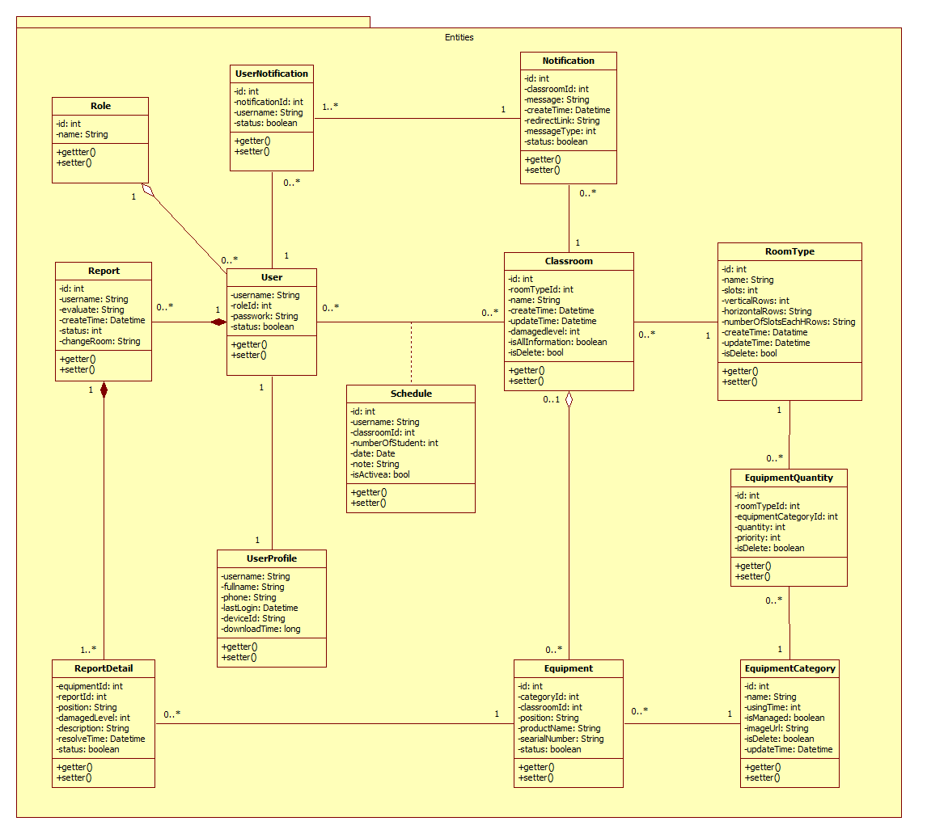

***Role***

|  |  |  |  |
| --- | --- | --- | --- |
| Attribute | Type | Visibility | Description |
| id | int | Private | Unique identifier of role |
| name | String | Private | Name of role |

***UserProfile***

|  |  |  |  |
| --- | --- | --- | --- |
| Attribute | Type | Visibility | Description |
| username | String | Private | Unique identifier of profile |
| fullname | String | Private | The full name’s account |
| email | String | Private | The user’s email |
| phone | String | Private | The user’s phone |
| lastLogin | String | Private | User login to system in last time |
| deviceId | String | Private | Smart phone’s id |
| downloadTime | Long | Private | Update equipment category version |

***User***

|  |  |  |  |
| --- | --- | --- | --- |
| Attribute | Type | Visibility | Description |
| username | String | Private | Unique identifier of account |
| password | String | Private | The user’s password |
| Status | boolean | Private | The user’s status |
| role | Role | Private | The user’s role |

***Report***

|  |  |  |  |
| --- | --- | --- | --- |
| Attribute | Type | Visibility | Description |
| id | String | Private | Unique identifier of account |
| username | String | Private | The username who create report |
| evaluate | String | Private | The user’s evaluate about room |
| createTime | Datetime | Private | The date create reporting |
| status | int | Private | The report’s status |
| changeRoom | String | Private | The room are changed |

***ReportDetail***

|  |  |  |  |
| --- | --- | --- | --- |
| Attribute | Type | Visibility | Description |
| equipmentId | int | Private | The damaged equipment’s id |
| reportId | int | Private | The report’s id |
| position | String | Private | The position of equipment in room |
| damagedLevel | int | Private | The equipment’s evaluate |
| description | String | Private | The damaged equipment’s description |
| resolveTime | Datetime | Private | The time of resolve equipment |
| Status | boolean | Private | The report detail’s status |

***EquipmentCategory***

|  |  |  |  |
| --- | --- | --- | --- |
| Attribute | Type | Visibility | Description |
| id | int | Private | Unique identifier of category |
| name | String | Private | The category equipment’s name |
| usingTime | int | Private | The number of hour equipment can use |
| isManaged | boolean | Private | The equipment is managed quantity |
| imageUrl | String | Private | The equipment’s image |
| isDelete | Boolean | Private | The category’s delete status |
| updateTime | Datetime | Private | The last update category |

***EquipmentQuantity***

|  |  |  |  |
| --- | --- | --- | --- |
| Attribute | Type | Visibility | Description |
| id | int | Private | Unique identifier of equipment quantity |
| roomTypeId | int | Private | The roomtype’s id |
| equipmentCategoryId | int | Private | The category equipment’s id |
| quantity | Int | Private | The number of equipment in roomtype |
| priority | int | Private | The equipment’s priority in roomtype |
| isDelete | Boolean | Private | The equipment quantity’s delete status |

***Equipment***

|  |  |  |  |
| --- | --- | --- | --- |
| Attribute | Type | Visibility | Description |
| id | int | Private | Unique identifier of equipment |
| categoryId | int | Private | The category’s id |
| classroomId | int | Private | The classroom’s id |
| position | String | Private | The equipment’s position in room |
| productName | String | Private | The equipment’s product name |
| serialNumber | String | Private | The equipment’s serial number |
| Status | boolean | Private | The equipment’s status |

***Classroom***

|  |  |  |  |
| --- | --- | --- | --- |
| Attribute | Type | Visibility | Description |
| id | int | Private | Unique identifier of classroom |
| roomTypeId | int | Private | The roomtype’s id |
| name | String | Private | The classroom’s name |
| createTime | Datetime | Private | The room was created in this date |
| updateTime | Datetime | Private | The room was updated in this date |
| isAllInformation | boolean | Private | Check complete room’s information |
| isDelete | boolean | Private | Check active or deactivate room |

***Schedule***

|  |  |  |  |
| --- | --- | --- | --- |
| Attribute | Type | Visibility | Description |
| id | int | Private | Unique identifier of schedule |
| username | String | Private | The teacher’s username |
| classroomId | int | Private | The classroom’s id |
| numberOfStudent | int | Private | The number of student in room |
| date | Date | Private | The date is schedule active |
| note | String | Private | The schedule’s note |
| isActive | boolean | Private | The schedule’s status |

***Roomtype***

|  |  |  |  |
| --- | --- | --- | --- |
| Attribute | Type | Visibility | Description |
| id | int | Private | Unique identifier of room type |
| name | String | Private | The teacher’s username |
| slots | int | Private | x |
| verticalRows | int | Private | The number of row in the room type |
| horizontalRows | String | Private | The number of horizontal row in vertical row |
| numberOfSlotsEachHRows | String | Private | The number of chair in horizontal row |
| createTime | Datetime | Private | The room type was created in this date |
| updateTime | Datetime | Private | The room type was created in this date |
| isDelete | bool | Private | Check active or deactivate room type |

***Notification***

|  |  |  |  |
| --- | --- | --- | --- |
| Attribute | Type | Visibility | Description |
| id | int | Private | Unique identifier of notification |
| classroomId | int | Private | The room’s id |
| message | String | Private | Content message of notify |
| createTime | Datetime | Private | The date create notify |
| redirectLink | String | Private | The link are redirected |
| messageType | int | Private | The message’s type of notify |
| status | boolean | Private | The notification’s status |

***UserNotification***

|  |  |  |  |
| --- | --- | --- | --- |
| Attribute | Type | Visibility | Description |
| id | int | Private | Unique identifier of user notification |
| notificationId | int | Private | The notification’ id |
| username | String | Private | User was received notification |
| status | boolean | Private | The user notification’s status |